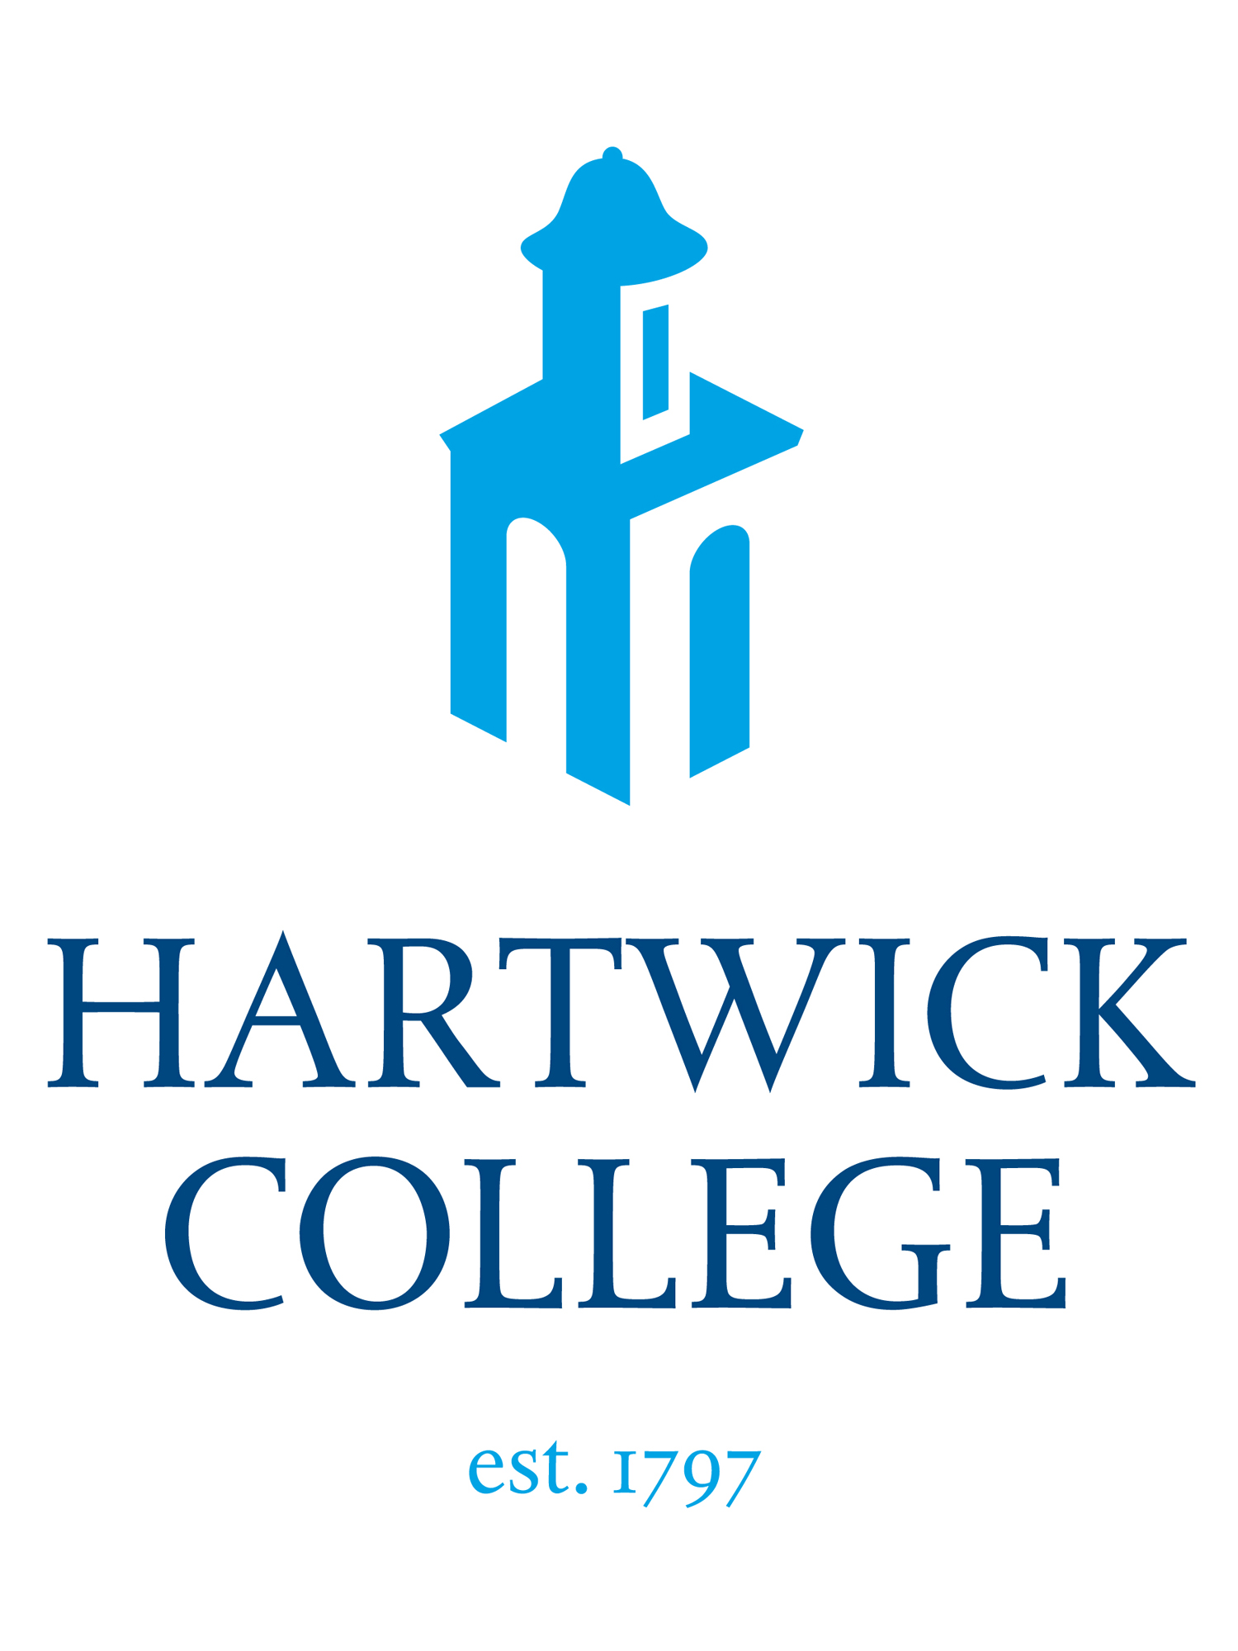

OTSEGO COUNTY CHAMBER OF COMMERCE
2020 INTERN OF THE YEAR AWARD
Eligibility:
- Must be nominated by a member business of the Otsego County Chamber.
- Nominated students must have been registered for one or more of their work terms between September 1st of the previous year and August 31st of the nominating year.
- Nominated students must be a junior or senior and enrolled at Hartwick College or the State University of New York (SUNY), College at Oneonta.
Award:
- The award recognizes outstanding achievement in, and contribution to, local and regional internships.
- Two students, one each from Hartwick and SUNY Oneonta will be selected.
- The business and the student intern will be honored and receive a recognition certificate at the Annual Otsego County Chamber Small Celebration to be held Virtually .

Additional Information:
- We request that each member business nominate only one individual for the award.
- The awards committee reserves the right to determine award eligibility.
- If you have a question about eligibility, please contact Barbara Ann Heegan.
Nomination Pack Must Include:
  - Application Form (page 2)
  - Student Resume
  - Member Business Support Statement

Member Business Support/Site Sponsor Statement:
One page double-spaced executive summary briefly discussing the following:
    - The student’s work-related duties, quantity and quality of work
    - Examples of how the student was challenged during their internship
    - Any published papers, presentation or other formal presentation of their work (Do not include, just discuss)
    - Any recognition or awards from the organization
    - The student’s involvement in the community
    - The student’s involvement in improving the organization’s internship program
    - The overall impact of this student on the organization at large
    - Any other pertinent information to support the nomination
Process:
Deadline: Friday, October 30th: Completed nomination packet must be received by this date.
- Early November: Interns of the Year will be selected and site sponsors will be notified
- Otsego County Small Business Celebration, and honoring of 2020 Interns of the Year to be held Virtually

Send completed Nomination Packet to:
Barbara Ann Heegan, Otsego County Chamber of Commerce, PO Box 18, Oneonta, NY 13820
or eMail to: baheegan@otsegocc.com
OTSEGO COUNTY CHAMBER
2020 INTERN OF THE YEAR AWARD APPLICATION

Date:

Award Applying For: ___ Hartwick College Intern of the Year ___ SUNY Oneonta Intern of the Year

Student Nominee Name:
Local Address:

Permanent Address:

Email:
Local Phone Number:____________________ Permanent Phone Number:____________________
Student Major: Cumulative GPA:

Member Business Nomination Contact Information
Member Business Name /Department:
Address:
Intern Supervisor Job Title:
Email: Phone Number:

Number of Internship Terms Completed:
Please list the company name and dates of all Co-Op/Internship terms completed in reverse chronological order:
Business/Org: Internship: ___ /___ to ___ /___ (MM/YY)
Business/Org: Internship: ___ /___ to ___ /___ (MM/YY)
Business/Org: Internship: ___ /___ to ___ /___ (MM/YY)
Business/Org: Internship: ___ /___ to ___ /___ (MM/YY)
Business/Org: Internship: ___ /___ to ___ /___ (MM/YY)

