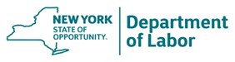
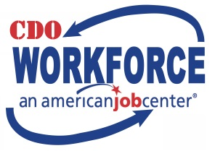
HEALTHCARE JOB FAIR
FOXCARE Center, 1 Foxcare Dr., Oneonta, NY 13820
Saturday 2/23/19 11am-2pm
PARTICIPATING BUSINESSES
Bassett Healthcare Network
Family Planning of South Central NY
UHS Hospitals
The ARC of Delaware County
The ARC of Otsego County
US Care Systems
AO Fox Hospital
Pathfinder Village
Chestnut Rehabilitation and Nursing Facility
Hampshire House
NYS Veteran’s Home (Oxford)
Mobile Life Transport
Springbrook
Catholic Charities
Chase Memorial Nursing Home and Rehab
Achieve

