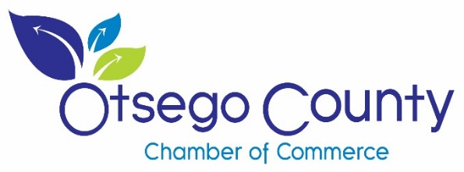
Laurens Central School
“Career Spark”
Summer Employment and Leadership Fair
Thursday, March 12, 2020
**********************
Otsego County Chamber
of Commerce
Job Fair Expo
Tuesday, March 31, 2020
Quality Inn of Oneonta, NY

The Otsego County Chamber of Commerce is pleased to be sponsoring TWO upcoming opportunities:

- The 2020 Career Spark at Laurens Central School for 9-12 grade students interested in learning about Career Opportunities and Summer Employment. Please join us as we provide two opportunities for both students and teachers looking for Summer Employment. Thursday, March 12, 2020: Session #1 (9am to 11:30am), Session #2 (12:30 – 2pm)
The event will take place on Thursday, March 12, 2020 from 9-11:30am and again from 12:30- 2:00pm, at Laurens Central School, 55 Main Street, Laurens, NY 13796. The following schools will also be participating Laurens, Milford, Morris and Edmeston. Lunch will be provided. Set up and registration will begin at 8:15am.
We are looking for a panel of presenters to start off each time period focusing on the types of employment opportunities available in our area, employer expectations, scheduling, job training, potential internships and full-time positions, and so forth. Break-out sessions will follow the panel discussion allowing students time to meet potential employers, learn how to properly complete applications, how to dress for an interview, resume building and so forth.

- The Otsego County Chamber of Commerce Job Fair Expo on Tuesday, March 31, 2020 at The Quality Inn of Oneonta. Set up is at 11:00a.m. & lunch is at Noon. Job Fair Expo will run 1:00p.m.-4:00p.m. This Job Fair is for all types of employment opportunities.

Please complete the registration form on the back: $70 registration fee ($50 for Non-Profits) includes participation in BOTH Employment Events! Space is limited, please send in your registration form and payment as soon as possible. Table and 2 chairs will be provided. Electrical access is limited and will be assigned on a first come, first serve basis. You must bring your own extension cords. (Outlets may be as far as ten feet away.) Please inform us if you have a large display so that we may assign you a booth against a wall. We also request if you can send us your job postings in advance so we can help encourage participation from job seekers we have in our database.
If you have any questions, please contact Kathryn Dailey Director of Special Events at (607) 432-4500 ext.2 or email Kathryn@otsegocc.com. Deadline to register is Friday, March 6, 2020.

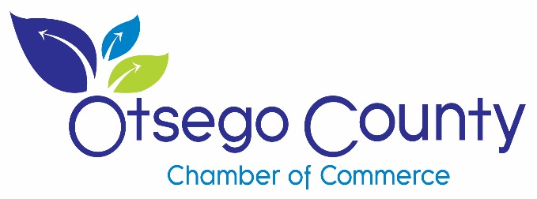

EXHIBITOR SPACE REGISTRATION for BOTH Events
Thursday, March 12 and Tuesday, March 31, 2020

Please type or print the following information legibly.

____ Indicate the # of chairs needed at your table. (Tables will be either 6’ or 8’)
____ Yes, I would like electrical access.
____ Yes, my business/ company is a Non-Profit
____ Yes, I have a large display or back drop (please assign me space against the wall so to not block others).
Lunch will be provided both days- let us know if you have any food restrictions. ___________________
My business is available to participate in only ________________ (date) event.

Set up for Career Spark 8:15am- Laurens Central School
Set up for Job Expo 11:00am – Quality Inn, Oneonta, NY

Company Name: _______________________________________________ Total # of Employees __________

Contact Person: ___________________________________________ Phone:(______) ________-___________

Mailing Address: ___________________________________________________________________________

Email Address: _____________________________________________________________________________

Company Website: __________________________________________________________________________

Mail payment to: Otsego County Chamber of Commerce, PO Box 18, Oneonta, NY 13820
Amount: ___$70 _ $50

______ Check Enclosed: Make check payable to: Otsego County Chamber of Commerce

Or

Select Card Type: _____VISA ____MASTERCARD ____DISCOVER ____AMERICAN EXPRESS

Card Number: ______________________________________ Expires ______/______ (mm/yy) SIC Code _______

Card Holder Name: ______________________________________ Signature: _______________________________

Dear Business Leaders,
The Otsego County Chamber of Commerce has TWO special career events coming up as an opportunity for businesses to find a qualified and skilled workforce for full time work and summer employment opportunities.
To assist with your job market needs we are partnering with the Laurens Central School District to have a Career Spark Day for 9-12 graders to illustrate to them the important skills needed for the current job market and the opportunities that exist in our region. Many of these students are also looking for summer job opportunities and internship opportunities. There are also teachers that are looking for summer employment that we have invited to also attend.
The event will take place on Thursday, March 12, 2020 from 9-11:30am and again from 12:30-2:00pm, at Laurens Central School, 55 Main Street, Laurens, NY 13796. The following schools will also be participating: Laurens, Milford, Morris and Edmeston. Lunch will be provided. Set up and registration will begin at 8:15am.
We are looking for a panel of presenters to start off each time period focusing on the types of employment opportunities available in our area, employer expectations, scheduling, job training, potential internships and so forth. Break-out sessions will follow the panel discussion allowing students time to meet potential employers, learn how to properly complete applications, how to dress for an interview, resume building and so forth.
We will also have a Job Fair Expo open to the public on Tuesday, March 31, 2020 at the Quality Inn of Oneonta from 1:00p.m.-4:00p.m. This is for all Job Opportunities: part time, full time, special events. Please include any internships and volunteering opportunities as well. This is a great way to reach out to the community and let potential employees know what you are looking for.
The success of these events is dependent on support from our many businesses participating in these opportunities where we provide your company with increased visibility and at the same time providing benefit to your organization’s recruitment efforts. Please see attached details for registration. For questions and more information please contact Barbara Ann Heegan @baheegan@otsegocc.com
Thank you for your support of these highly visible and well publicized events. We believe this is a great value to be able to reach such a wide spectrum of job seekers and have an impact on young potential employees in our region at the same time.
If you are unable to participate in both events, please contact us!
Respectfully,

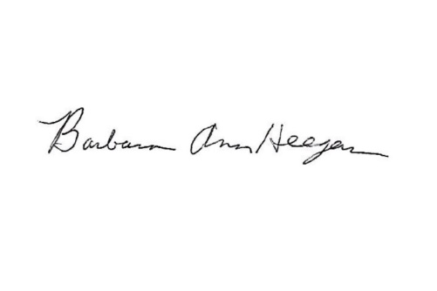
Barbara Ann Heegan
President & CEO
Otsego County Chamber of Commerce

