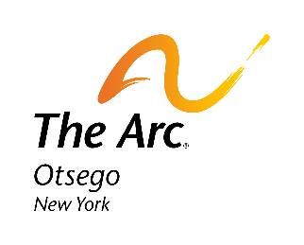
Contact: Faith Tiemann
607-433-8427
tiemannf@arcotsego.org
FOR IMMEDIATE RELEASE:
Todd Hansen Promoted to Chief Executive Officer of The Arc Otsego

Oneonta, NY (June 7, 2021) Todd Hansen has been promoted to Chief Executive Officer of The Arc Otsego, following the retirement of Pat Knuth. Todd joined the leadership team in 2016 as the Chief Operations Officer and Assistant Executive Director. Since his arrival, Todd has helped to grow the services and supports The Arc Otsego provides, including the residential and day programs, employment and community-based services, facilities, and maintenance of 17 sites based through Otsego County.
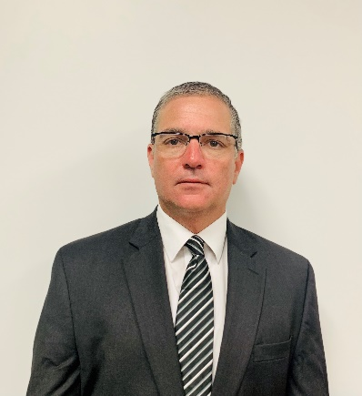
Todd has a wealth of experience in supporting individuals with intellectual and developmental disabilities (IDD), starting as a Direct Support Professional (DSP) in the early 90’s and continuing on a path of increased leadership and responsibility. For 10 years prior to joining the Arc Otsego, he was Executive Director/Regional Vice President for Community Options, NY. His achievements include program development, securing funding for innovative projects, expansion of services and revenue, and the oversight and support of hundreds of staff and individuals.

In addition to program operations at the Arc Otsego, Todd is an active leader, overseeing several initiatives within the organization at both the local chapter level and statewide. He was part of the inaugural 2019 Arc Leadership Institute, a yearlong leadership exercise to assist the next generation of executives in making a successful transition. He has actively participated in local, regional, and national events, such as the annual Disability Policy Seminar in Washington D.C., where he has been a strong advocate for increased services and supports.
Todd Hansen, Chief Executive Officer of The Arc Otsego

As the new CEO, Todd will work closely with staff and the board to ensure the organization can continue to grow in its support of individuals and provide meaningful career opportunities to the employees of the agency. His positive attitude and innovative ideas around recruitment and retention will lead The Arc Otsego into 2021 and beyond with a strong strategic plan.

About The Arc Otsego: A group of dedicated and caring parents, relatives, friends and concerned professionals, formed the Otsego County Chapter of the New York State Association for Retarded Children on May 10, 1965. The group served primarily as a support organization until 1974 when The Arc Otsego opened a sheltered employment facility. Soon after, day services became available at the Hartwick Day Treatment facility. With the founding of our first residential intermediate care facility, The Arc Otsego become a 24/7 operation. in 1989, the agency built Oneonta Day Services and expanded day services to include more individuals with physical disabilities. In 1993, The Arc Otsego enrolled in the NYS Home and Community-Based Waiver and began offering more services to families in their own homes. Today, the agency offers comprehensive, community-based services, supports and programs to over 500 individuals with intellectual and other developmental disabilities and their families throughout Otsego County. The Arc Otsego helps adults with intellectual and other developmental disabilities fulfill their personal dreams and ambitions. At The Arc Otsego, each person meets with a team of dedicated and caring staff to develop a unique life plan. Each plan is designed to reflect the individual’s talents, interests, and desired outcomes. The Arc Otsego’s person-centered approach is driven by the individual, focusing on gifts and abilities. This approach is visionary and future-oriented.

**************************************************************************************
The Arc Otsego, a chapter of The Arc New York, is a private, not-for-profit organization offering comprehensive, community-based services to individuals with developmental disabilities and their families throughout Otsego County, NY. For more information, visit www.arcotsego.org or call 607-432-8595.

